Project 1 (Option B)
Steve Mazza
Given: I am the lead systems engineer for a new surveillance Unmanned Aircraft System (UAS). The system will be a persistent maritime intelligence, surveillance, and reconnaissance (ISR) data collection and dissemination capability that fulfills the maritime war fighter’s requirement for continuous battle-space awareness.

Brief description of the systems engineering process
We will begin with the identification of all stakeholders and start building Use Cases around a concept of operations. We will simultaneously interview as many stakeholders as possible for requirements, some of which will be defined within other systems. Effective identification of systems with which we will be required to integrate will be critical to our success. In each case we will obtain or create documentation for applicable interfaces and standards that will ultimately be captured as part of our requirements definition. As we begin collecting requirements, we will perform an analysis of existing commercial off-the-shelf (COTS) and government off-the-shelf (GOTS) to see if a suitable solution can be leveraged.

Software engineering process model description
Due to the cost and critical nature of the UAS project, I am recommending the use of the standard INCOSE V-model for software development. This will facilitate the formal capture and documentation of system requirements from the UAS aeronautical engineers, shipboard requirements, Command & Control integration, and flight control constraints. This engineering model also has the benefit of following a predictable development schedule that makes backward scheduling feasible.
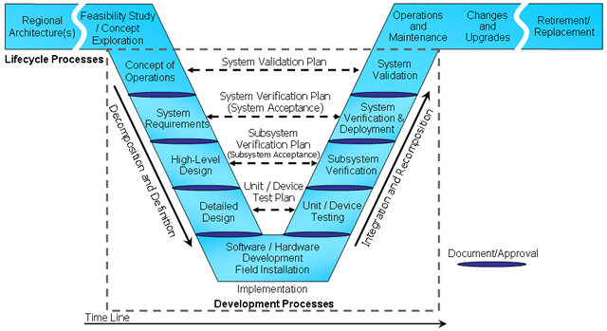

Concept of Operations
The initial step labeled Concept of Operations above is comprised of collecting user requirements, developing the system concept, and developing the System Validation Plan. This step helps us ultimately formulate a strong concept around what we are going to build, what the operating environment looks like (including other systems), and who will be interacting with the system.

System Requirements
Proper identification of system requirements allows us to ultimately verify that the system has been built correctly and is, inasmuch, one of the most critical steps in the software engineering process. Requirements shall be written in accordance with guidance presented in “Writing Quality Requirements” by Karl Wiegers. The System Requirements Document and the System Verification Plan are principal work products from this phase of engineering.

High-Level Design
This is a top level functional decomposition that results in the identification of the major system components. The step facilitates resource planning by providing a natural division of labor among the software development team and provides a roadmap to abstraction through encapsulation of functionality. This helps establish boundaries and interfaces within the software that suggest viable software models, solution spaces, architectures, frameworks, and language choices.

Detailed Design
Here we extend the top level decomposition by fleshing out a detailed architecture for each of the modules. Further decomposition at this level continues until the design is complete. This will include business logic, persistence models (e.g., binary data structures or detailed database design), interface specifications, and unit tests. The result of this phase will remove any heavy lifting from the software development.

Software Development
Software development is where the code is written. The detailed and high-level design will be implemented here and in many cases unit tests written ahead of time will be applied as an integral part of the code, compile, debug process referred to as Test Driven Design.

Unit Testing
Unit testing is a means to determine from the ground up if the developed software meets the detailed design specifications. Often static analysis tools are employed to automate the complete traversal of all branches of logic within a given unit of code. Inputs for logic are chosen based on the identification of boundary conditions.

Subsystem Verification
This is also referred to as Integration Testing. The goal is to bring all of the units of code together and focus on verifying the interfaces and data passed between modules. Assuming successful Unit Testing, the actual code in the unit modules is not usually directly inspected, a technique referred to as black box testing.

System Verification
The system is field tested and closely compared against the system specifications and requirements. Accountability must be both thorough and accurate.

System Validation
The primary components of this step in the software engineering process are Delivery and User Acceptance Testing. Given sufficient diligence in the Definition and Design phases, there should be no surprises here.

Defense Acquisition System to software engineering process mapping
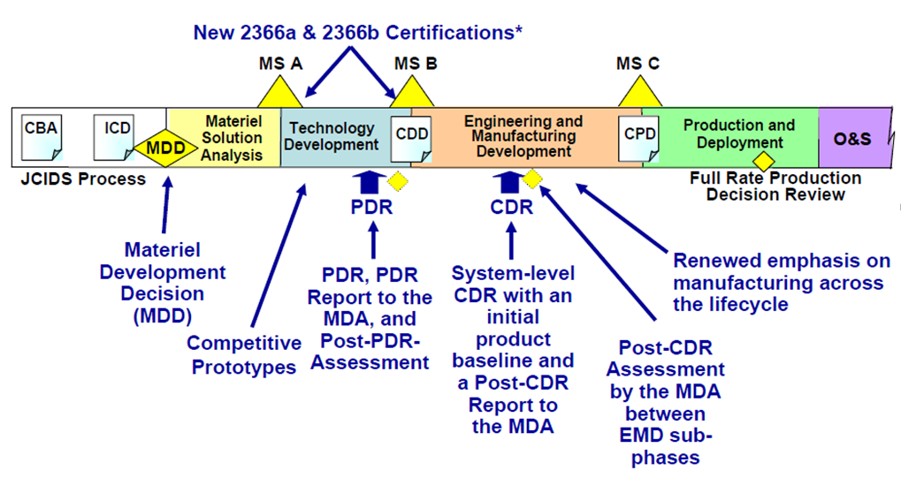

Identification of candidate Agile within DoD Acquisition
While Agile methods could potentially be implemented at any point in the software development process, the natural fit is during the software development phase. Having a clear specification in hand, developers could embark on 2- to 4-week sprints resulting in an earlier look at the finished product.
A more holistic approach might be to also include the detailed design and unit testing into the scrum. This broadens the cycle but provides increased value in that it allows an iterative approach to the testing and development cycle. Every few iterations could trigger a larger integration test and result in the early delivery of portions of the functionality to the integration systems (e.g., UAS hardware team) for early testing.

Considerations for choosing a programming language
There are several considerations when choosing a programming language for use in this UAS project, the first of which may be the consideration of the runtime environment. In this case it is likely that there will be a nontrivial embedded systems component that will require code to be written in a domain specific language or at very least within an environment that is capable of compiling, say C, into embedded machine code. Either way, choices that satisfy this requirement will even in the best cases be limited.
A language that is well suited for use in this problem space will provide access to data structures and operations on those data structures that facilitate interaction with the hardware and the subsequent creation of solutions within the problem domain. An example of this might be a means to facilitate real time collection of data from an analog port for use in stabilizing flight control.
Existing licensing and programmer proficiency will also play a part in language selection.

Approaches to modeling
Modeling can occur on a number of different levels. Individual system components can be modeled to ensure they will meet or exceed the necessary standards. Known data from components such as IR sensors, video cameras, and flight controls can be leveraged to ensure that sample rates, effective ranges, and environmental tolerances are sufficient to work in a variety of simulated environments. The interactions between these system components can also be modeled in anticipation of any integration issues.
Standard and specialized aeronautical models can be applied to help forecast range, maneuverability, stealth, and payload for the UAS.
At a much higher level, collected mission data can be modeled to assist with integration into existing Intelligence and Information (I2) warfare systems. The whole UAS along with simulated mission data can be modeled for overall mission effectiveness, cost in dollars, and projected cost savings to human lives using a high level modeling tool such as ExtendSim. This can help shed light on developing scenarios for mission success and contingency planning.

